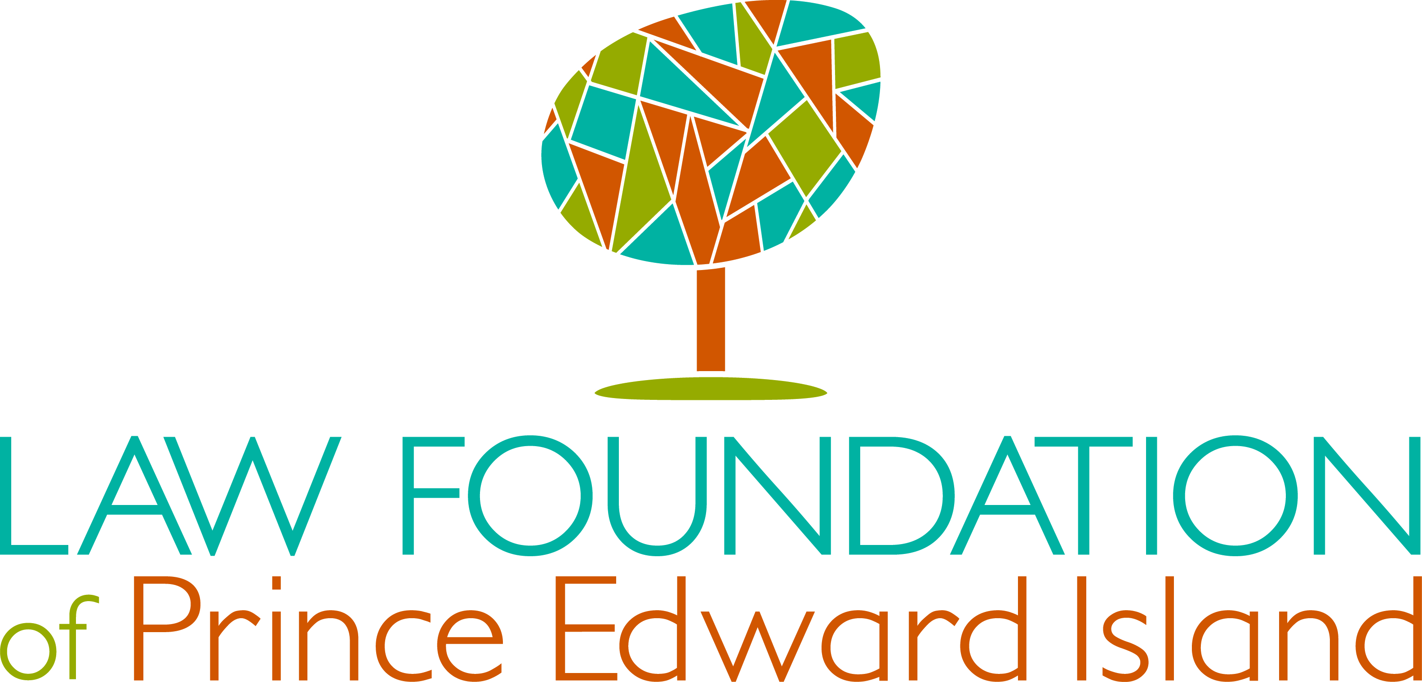

Project Application Form
(Required for All Applications)
Name of Organization:

Address:

City: | Province: |  |  | Postal Code:
Contact Person: |  | Position:
Telephone: |  | Fax:
E-mail: |  | Website (if applicable):
Mandate of Organization (1-2 sentences – supplementary information may be attached):

Organization Type:
Not-for-profit  Date of incorporation:______________  Registered Charity  Registered Charity Number:____________ |  |  | University or College**  Other -please describe:  _________________________
Title of Project:
Start Date: |  | End Date:
If applying for a conference, workshop, symposium, or similar event, indicate the date(s) of the event:
Request Amount: |  | $
Total Budget for Project (excluding in-kind): |  | $
Estimate Value of In-Kind (if applicable): |  | $
Total Project Value (cash and in-kind): |  | $
Please briefly describe your proposed activities (2 sentences or less):

Please indicate which project category you are applying under (check all that apply):

Legal aid Access to Justice Legal research Legal education Technology
Signature: |  | Title:
Name: |  | Date:

¹ By signing this form, you are agreeing to the terms and conditions as set out in Appendix “A” – Terms and Conditions of Grant Acceptance (see next page) APPENDIX “A” THE FOLLOWING CONDITIONS OF A GRANT ARE UNDERSTOOD AND ACCEPTED: By signing this form, the applicant agrees that, unless otherwise specifically stated in writing by the Law Foundation of Prince Edward Island, this funding, if approved, is solely applicable for the year and project for which it is made, and it cannot be assumed that funding will continue to be provided for subsequent year(s) and project(s), as further funding may require reapplication. The applicant agrees that, if the grant requested is approved by the Law Foundation of Prince Edward Island, the funds provided will be used as specified in this application, or any variation approved in writing by this Law Foundation, and any unused portion of the grant will be returned to the Law Foundation forthwith following the completion date of the project, or such earlier date as the Law Foundation decides during the project. The applicant agrees that all material produced as a result of a grant from the Foundation (written, printed, videotaped, etc.) will be provided without charge to the Law Foundation of Prince Edward Island. The applicant agrees that it will comply with the Law Foundation of Prince Edward Island’s “Recognition of Support” policy. The applicant agrees to comply with all applicable legislation when carrying out this program/project, including federal and provincial Human Rights Acts and employment legislation. Failure to comply with this condition shall constitute default and the Foundation shall have no further obligation to provide grant monies. The Foundation shall also have the right to reclaim in their entirety all monies paid in connection with this grant. The applicant authorizes the Law Foundation of Prince Edward Island to make inquiries of and obtain such other information from any persons, institutions or organizations as the Foundation may require in connection with this application.

